[Skip to main content](https://courses.myclass.skillup.online/courses/course-v1:IBM+AI101+2023_17/f58f3bd7c9d3442584ecd1fea784dd17/#main)

**[SkillUp Online Home Page](https://courses.skillup.online/)**

**IBM: AI101Artificial Intelligence - Rajah Serfoji Govt College**

* [D](javascript:void(0);)

1. [Course](https://courses.myclass.skillup.online/courses/course-v1:IBM+AI101+2023_17/course/)

1. [Progress](https://courses.myclass.skillup.online/courses/course-v1:IBM+AI101+2023_17/progress)

1. [Dates](https://courses.myclass.skillup.online/courses/course-v1:IBM+AI101+2023_17/dates)

1. [Course Instructions, current location](https://courses.myclass.skillup.online/courses/course-v1:IBM+AI101+2023_17/f58f3bd7c9d3442584ecd1fea784dd17/)

1. [Discussion](https://courses.myclass.skillup.online/courses/course-v1:IBM+AI101+2023_17/discussion/forum/)

1. [Learner Planner](https://courses.myclass.skillup.online/courses/course-v1:IBM+AI101+2023_17/af050a1d2243465e8262c67543cefdb2/)

**Instruction Guidelines**   
  
The entire course outline can be seen when you click on the Course Tab on top.

Entire course is divided into 8 modules.

In some module you can find course links which will redirect you to a similar course related readings. In these courses, you will find all the study content.

Course completion is not mandatory but if you do you will get an IBM certificate for the same if you complete these courses.

After each module , there will be graded assessments (MCQs) to be taken.

After you go through the modules you will then need to proceed with the project. Guidelines for the same are mentioned below

**Project Guidelines**

Team of 5 can opt for 1 project

Instruction given for team creation and project selection

Once you are allotted the project you will be able to view your project in the LMS.

PROJECT SUBMISSION GUIDELINES

The project is divided into 7 parts. Please find the details below on how and what to submit in each part:

**PART 1: Problem Definition and Design Thinking**

In this part you will need to understand the problem statement and create a document on what have you understood and how will you proceed ahead with solving the problem. Please think on a design and present in form of the document.

After completion go to the part 1 section and upload your file in the space provided and click on submit. Please note you need to upload the same file twice in two section one after the other as there will be two evaluation taking place

**PART 2: Innovation and Problem Solving**

In this section you need to put your design into innovation to solve the problem. Create a doc around it and share the same for assessment

After completion go to the part 2 section and upload your file in the space provided and click on submit. Please note you need to upload the same file twice in two section one after the other as there will be two evaluation taking place.

**PART 3: Import the Dataset & Data Cleaning**

In this step you need to import the dataset provided. First understand the data and then perform data cleaning. You will be working on a python notebook in this step.

After completion go to the part 3 section and upload your saved notebook in the space provided and click on submit. Please note you need to upload the same file twice in two section one after the other as there will be two evaluation taking place.

**PART 4: Perform Data Analysis**

In this step you perform data analysis after the data gets cleaned. There will be details provided in the notebook itself on what type of analysis needs to be done. You will be working on the same python notebook from the above step.

After completion go to the part 4 section and upload your saved notebook in the space provided and click on submit. Please note you need to upload the same file twice in two section one after the other as there will be two evaluation taking place.

**PART 5: Perform Data Visualization**

In this step you perform data visualization after the data analysis is done. There will be details provided in the notebook itself on what all data needs to be visualized. You will be working on the same python notebook from the above step.

After completion go to the part 5 section and upload your saved notebook in the space provided and click on submit. Please note you need to upload the same file twice in two section one after the other as there will be two evaluation taking place.

**PART 6: Model Development & Evaluation**

In this step you build a model and evaluate the same. You will be working on the same python notebook from the above step.

After completion go to the part 6 section and upload your saved notebook in the space provided and click on submit. Please note you need to upload the same file twice in two section one after the other as there will be two evaluation taking place.

**PART 7: Project Documentation & Testing**

In this step you will perform testing for verification purpose. After that you will be required to create a presentation where you need to document all your findings in detail from part 1 onwards. This document that you create will summarize your entire project journey.

After completion go to the part 7 section and upload your document in the space provided and click on submit. Please note you need to upload the same file twice in two section one after the other as there will be two evaluation taking place.

[https://courses.skillup.online/static/Openedx-theme/skillup_static/images/logo-wide-w.png](https://courses.skillup.online/)

A blended learning platform for IT students and professionals looking to take the next steps in their career.

* [Blog](https://blog.skillup.online/)
* [FAQs](https://skillup.online/faq)
* [Press](https://skillup.online/press)
* [Contact us](https://skillup.online/contact)
* [Terms of Service](https://skillup.online/tos)
* [Privacy Policy](https://skillup.online/privacy)
* [**About Us**](https://skillup.online/about)
* [**For Business**](https://skillup.online/enterprise)

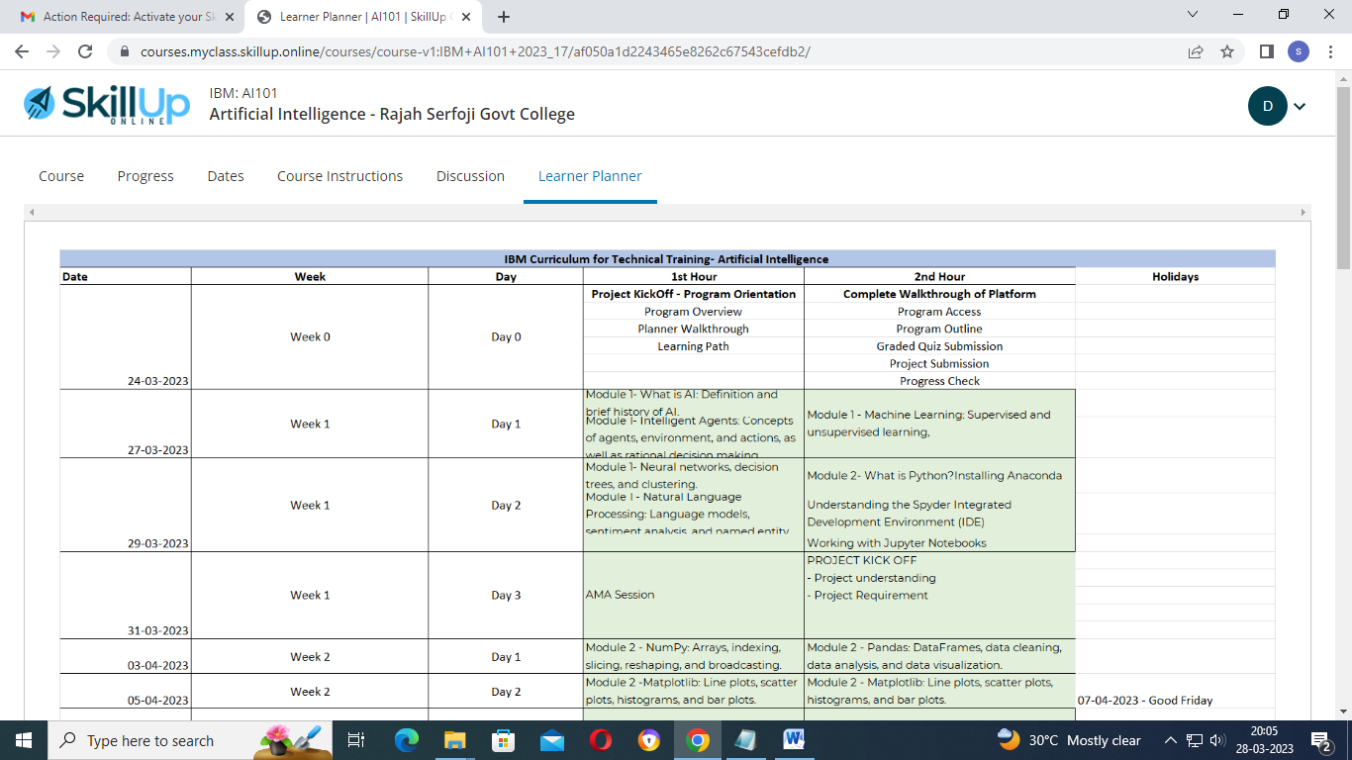

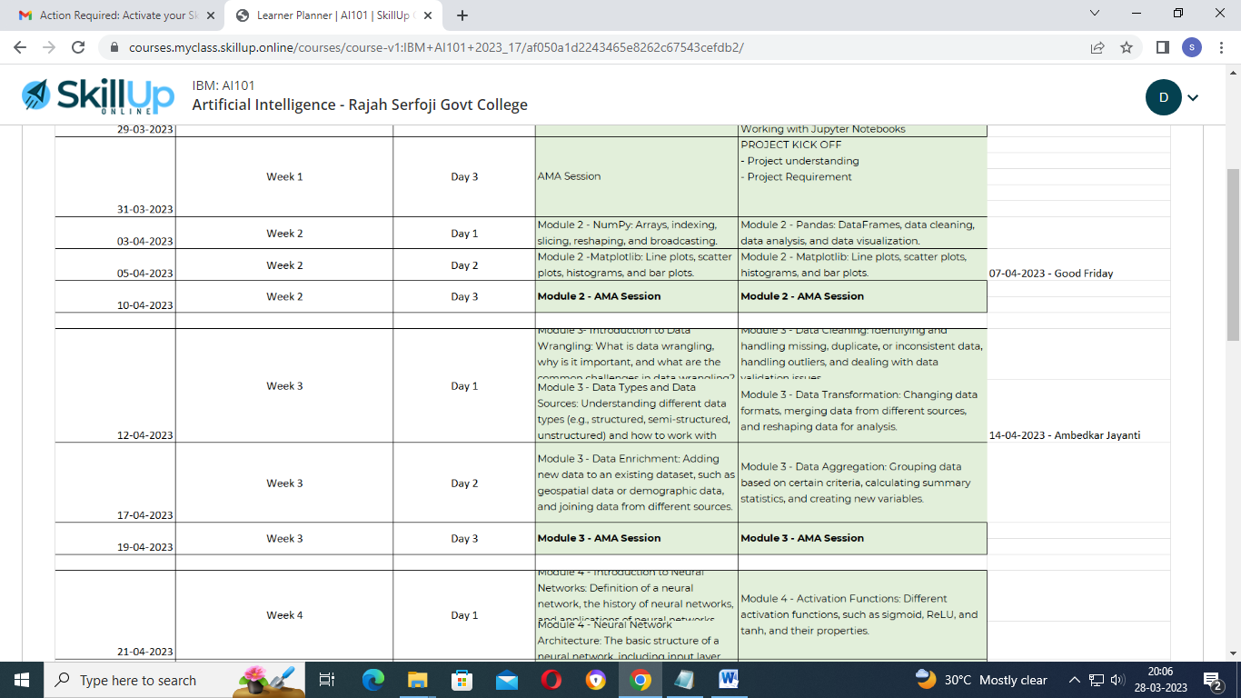

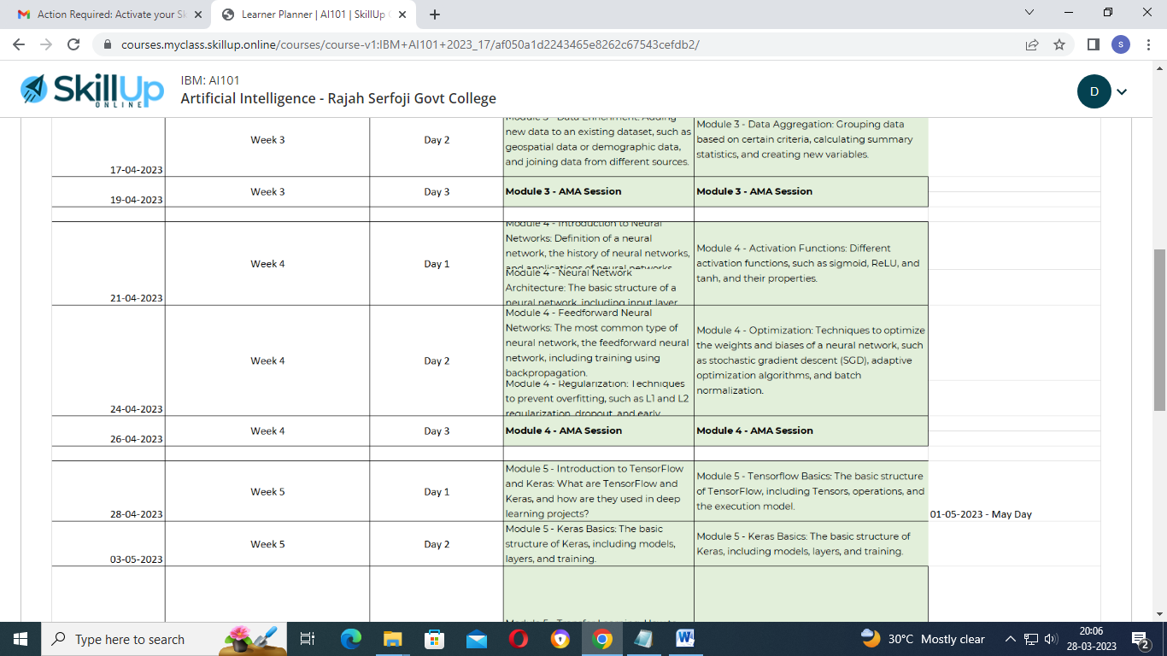

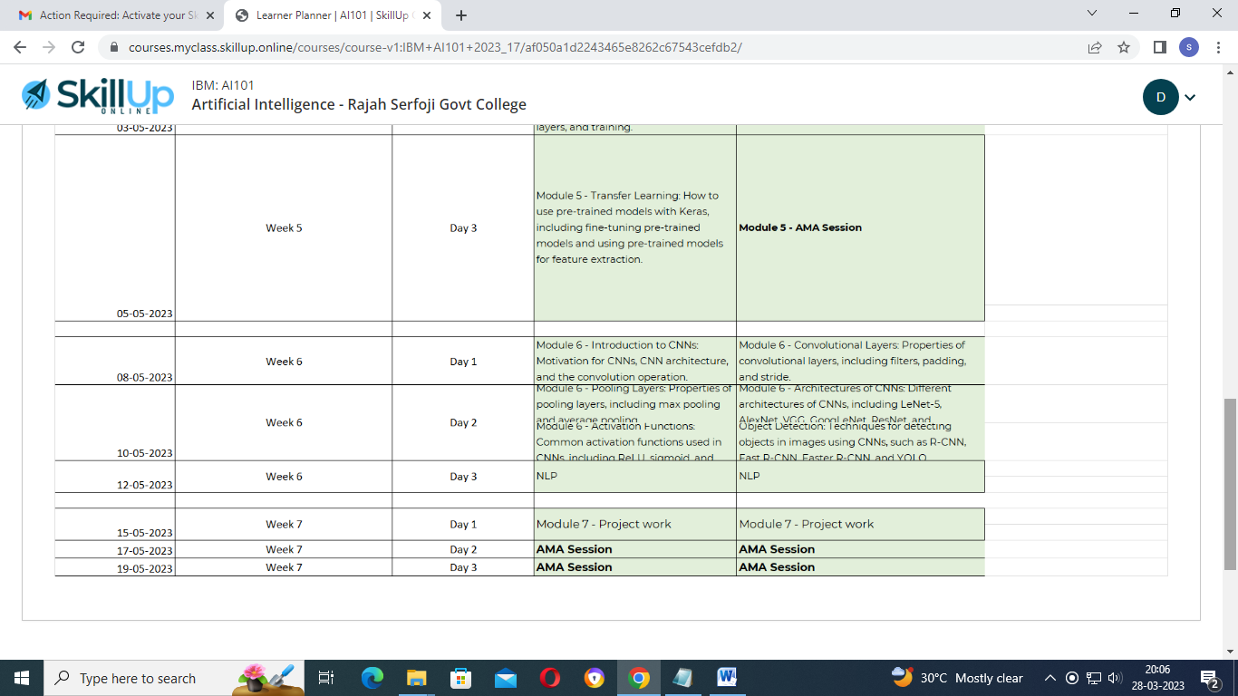

[Skip to main content](https://courses.myclass.skillup.online/courses/course-v1:IBM+AI101+2023_17/course/#main)

# [SkillUp Online Home Page](https://courses.skillup.online/)

# IBM: AI101Artificial Intelligence - Rajah Serfoji Govt College

* [D](javascript:void(0);)
* [**Course, current location**](https://courses.myclass.skillup.online/courses/course-v1:IBM+AI101+2023_17/course/)
* [**Progress**](https://courses.myclass.skillup.online/courses/course-v1:IBM+AI101+2023_17/progress)
* [**Dates**](https://courses.myclass.skillup.online/courses/course-v1:IBM+AI101+2023_17/dates)
* [**Course Instructions**](https://courses.myclass.skillup.online/courses/course-v1:IBM+AI101+2023_17/f58f3bd7c9d3442584ecd1fea784dd17/)
* [**Discussion**](https://courses.myclass.skillup.online/courses/course-v1:IBM+AI101+2023_17/discussion/forum/)
* [**Learner Planner**](https://courses.myclass.skillup.online/courses/course-v1:IBM+AI101+2023_17/af050a1d2243465e8262c67543cefdb2/)

## Artificial Intelligence - Rajah Serfoji Govt College

[Start Course](https://courses.myclass.skillup.online/courses/course-v1:IBM+AI101+2023_17/jump_to/block-v1:IBM+AI101+2023_17+type@html+block@e116eb794730469a8ad92d69936f7d80)

Expand All



### Getting Started

#### [Project Selection](https://courses.myclass.skillup.online/courses/course-v1:IBM+AI101+2023_17/jump_to/block-v1:IBM+AI101+2023_17+type@sequential+block@8ac038a7bc164f7b9dc93210c18c0dc6)



### Module 1 : Introduction to Artificial Intelligence



### Project



### Project Submission PART 1: Problem Definition and Design Thinking



### Module 2: Python for Artificial Intelligence



### Project Submission PART 2: Innovation and Problem Solving



### Module 3: Data Wrangling Techniques



### Project Submission PART 3: Import the Dataset & Data Cleaning



### Module 4: Introduction to Neural Networks



### Project Submission PART 4: Perform Data Analysis



### Module 5: Tensorflow & Keras



### Project Submission PART 5: Perform Data Visualization



### Module 6: Convolutional Neural Networks



### Project Submission PART 6: Model Development & Evaluation



### Module 7 : Natural Language Processing



### Module 8: Build and Deploy AI Applications



### Final Project Submission - Project Documentation & Testing



### Session Recordings



### Session PPTs

### Course Tools

* [Bookmarks](https://courses.myclass.skillup.online/courses/course-v1:IBM+AI101+2023_17/bookmarks/)

[https://courses.skillup.online/static/Openedx-theme/skillup_static/images/logo-wide-w.png](https://courses.skillup.online/)

A blended learning platform for IT students and professionals looking to take the next steps in their career.

* [Blog](https://blog.skillup.online/)
* [FAQs](https://skillup.online/faq)
* [Press](https://skillup.online/press)
* [Contact us](https://skillup.online/contact)
* [Terms of Service](https://skillup.online/tos)
* [Privacy Policy](https://skillup.online/privacy)
* [**About Us**](https://skillup.online/about)
* [**For Business**](https://skillup.online/enterprise)

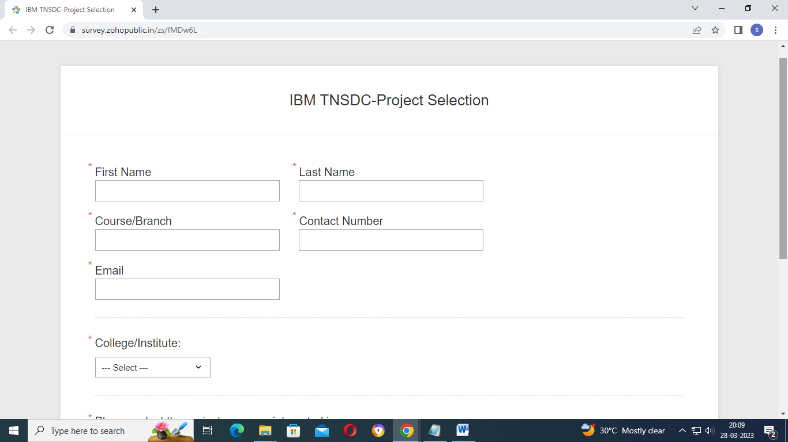

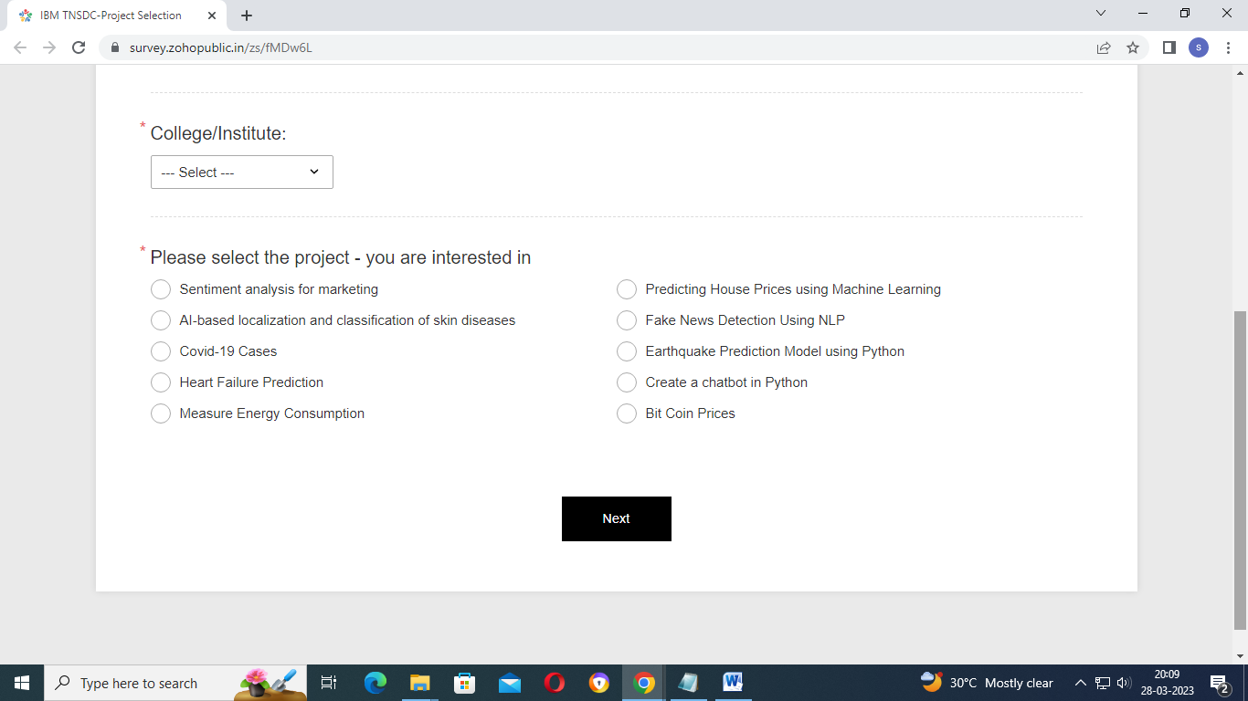

[Skip to main content](https://courses.myclass.skillup.online/courses/course-v1:IBM+AI101+2023_17/course/#main)

# [SkillUp Online Home Page](https://courses.skillup.online/)

# IBM: AI101Artificial Intelligence - Rajah Serfoji Govt College

* [D](javascript:void(0);)
* [**Course, current location**](https://courses.myclass.skillup.online/courses/course-v1:IBM+AI101+2023_17/course/)
* [**Progress**](https://courses.myclass.skillup.online/courses/course-v1:IBM+AI101+2023_17/progress)
* [**Dates**](https://courses.myclass.skillup.online/courses/course-v1:IBM+AI101+2023_17/dates)
* [**Course Instructions**](https://courses.myclass.skillup.online/courses/course-v1:IBM+AI101+2023_17/f58f3bd7c9d3442584ecd1fea784dd17/)
* [**Discussion**](https://courses.myclass.skillup.online/courses/course-v1:IBM+AI101+2023_17/discussion/forum/)
* [**Learner Planner**](https://courses.myclass.skillup.online/courses/course-v1:IBM+AI101+2023_17/af050a1d2243465e8262c67543cefdb2/)

## Artificial Intelligence - Rajah Serfoji Govt College

[Start Course](https://courses.myclass.skillup.online/courses/course-v1:IBM+AI101+2023_17/jump_to/block-v1:IBM+AI101+2023_17+type@html+block@e116eb794730469a8ad92d69936f7d80)

Collapse All



### Getting Started

#### [Project Selection](https://courses.myclass.skillup.online/courses/course-v1:IBM+AI101+2023_17/jump_to/block-v1:IBM+AI101+2023_17+type@sequential+block@8ac038a7bc164f7b9dc93210c18c0dc6)



### Module 1 : Introduction to Artificial Intelligence

#### [Introduction to AI](https://courses.myclass.skillup.online/courses/course-v1:IBM+AI101+2023_17/jump_to/block-v1:IBM+AI101+2023_17+type@sequential+block@4a5834cafac147f9b156767d0d13fd0e)



### Project

#### [Assigned Project](https://courses.myclass.skillup.online/courses/course-v1:IBM+AI101+2023_17/jump_to/block-v1:IBM+AI101+2023_17+type@sequential+block@ffb45e2c0733406389fd88c32c82e741)



### Project Submission PART 1: Problem Definition and Design Thinking

#### [Submission Part 1](https://courses.myclass.skillup.online/courses/course-v1:IBM+AI101+2023_17/jump_to/block-v1:IBM+AI101+2023_17+type@sequential+block@1133ebfa86ee43d0949b5504dcaae66e)

[Project This content is graded](https://courses.myclass.skillup.online/courses/course-v1:IBM+AI101+2023_17/jump_to/block-v1:IBM+AI101+2023_17+type@sequential+block@1133ebfa86ee43d0949b5504dcaae66e)



### Module 2: Python for Artificial Intelligence

#### [Python](https://courses.myclass.skillup.online/courses/course-v1:IBM+AI101+2023_17/jump_to/block-v1:IBM+AI101+2023_17+type@sequential+block@0df4c1f89b2e43a3aaed4c016d2ddc07)



### Project Submission PART 2: Innovation and Problem Solving

#### [Submission Part 2](https://courses.myclass.skillup.online/courses/course-v1:IBM+AI101+2023_17/jump_to/block-v1:IBM+AI101+2023_17+type@sequential+block@597a527379c14676b2273d3ea6fa0f08)

[Project This content is graded](https://courses.myclass.skillup.online/courses/course-v1:IBM+AI101+2023_17/jump_to/block-v1:IBM+AI101+2023_17+type@sequential+block@597a527379c14676b2273d3ea6fa0f08)



### Module 3: Data Wrangling Techniques

#### [Data Wrangling](https://courses.myclass.skillup.online/courses/course-v1:IBM+AI101+2023_17/jump_to/block-v1:IBM+AI101+2023_17+type@sequential+block@bb78f5acd4a8461ea7f61348d09a4015)



### Project Submission PART 3: Import the Dataset & Data Cleaning

#### [Submission Part 3](https://courses.myclass.skillup.online/courses/course-v1:IBM+AI101+2023_17/jump_to/block-v1:IBM+AI101+2023_17+type@sequential+block@1b72c04585c445e58beb71e2f6e75d24)

[Project This content is graded](https://courses.myclass.skillup.online/courses/course-v1:IBM+AI101+2023_17/jump_to/block-v1:IBM+AI101+2023_17+type@sequential+block@1b72c04585c445e58beb71e2f6e75d24)



### Module 4: Introduction to Neural Networks



### Project Submission PART 4: Perform Data Analysis

#### [Submission Part 4](https://courses.myclass.skillup.online/courses/course-v1:IBM+AI101+2023_17/jump_to/block-v1:IBM+AI101+2023_17+type@sequential+block@247633adc69e4dc2b9c43dbe9354e406)

[Project This content is graded](https://courses.myclass.skillup.online/courses/course-v1:IBM+AI101+2023_17/jump_to/block-v1:IBM+AI101+2023_17+type@sequential+block@247633adc69e4dc2b9c43dbe9354e406)



### Module 5: Tensorflow & Keras

#### [Tensorflow & Keras](https://courses.myclass.skillup.online/courses/course-v1:IBM+AI101+2023_17/jump_to/block-v1:IBM+AI101+2023_17+type@sequential+block@603b00e92b194ee3a761121b9599c1ab)



### Project Submission PART 5: Perform Data Visualization

#### [Submission Part 5](https://courses.myclass.skillup.online/courses/course-v1:IBM+AI101+2023_17/jump_to/block-v1:IBM+AI101+2023_17+type@sequential+block@9aaae33dfbf846fdba04c785bf7033e8)

[Project This content is graded](https://courses.myclass.skillup.online/courses/course-v1:IBM+AI101+2023_17/jump_to/block-v1:IBM+AI101+2023_17+type@sequential+block@9aaae33dfbf846fdba04c785bf7033e8)



### Module 6: Convolutional Neural Networks

#### [CNN](https://courses.myclass.skillup.online/courses/course-v1:IBM+AI101+2023_17/jump_to/block-v1:IBM+AI101+2023_17+type@sequential+block@4dffe64184a148a082d58a7f3e31cc79)



### Project Submission PART 6: Model Development & Evaluation

#### [Submission Part 6](https://courses.myclass.skillup.online/courses/course-v1:IBM+AI101+2023_17/jump_to/block-v1:IBM+AI101+2023_17+type@sequential+block@a9d105b63901489b89ca78197927d5f9)

[Project This content is graded](https://courses.myclass.skillup.online/courses/course-v1:IBM+AI101+2023_17/jump_to/block-v1:IBM+AI101+2023_17+type@sequential+block@a9d105b63901489b89ca78197927d5f9)



### Module 7 : Natural Language Processing

#### [NLP](https://courses.myclass.skillup.online/courses/course-v1:IBM+AI101+2023_17/jump_to/block-v1:IBM+AI101+2023_17+type@sequential+block@d469231e26c041759508c3beeb61cf1d)



### Module 8: Build and Deploy AI Applications



### Final Project Submission - Project Documentation & Testing

#### [Final Submission](https://courses.myclass.skillup.online/courses/course-v1:IBM+AI101+2023_17/jump_to/block-v1:IBM+AI101+2023_17+type@sequential+block@d9c95f2d42124ba082a842fb5de79197)

[Project This content is graded](https://courses.myclass.skillup.online/courses/course-v1:IBM+AI101+2023_17/jump_to/block-v1:IBM+AI101+2023_17+type@sequential+block@d9c95f2d42124ba082a842fb5de79197)



### Session Recordings



### Session PPTs

### Course Tools

* [Bookmarks](https://courses.myclass.skillup.online/courses/course-v1:IBM+AI101+2023_17/bookmarks/)

[https://courses.skillup.online/static/Openedx-theme/skillup_static/images/logo-wide-w.png](https://courses.skillup.online/)

A blended learning platform for IT students and professionals looking to take the next steps in their career.

* [Blog](https://blog.skillup.online/)
* [FAQs](https://skillup.online/faq)
* [Press](https://skillup.online/press)
* [Contact us](https://skillup.online/contact)
* [Terms of Service](https://skillup.online/tos)
* [Privacy Policy](https://skillup.online/privacy)
* [**About Us**](https://skillup.online/about)
* [**For Business**](https://skillup.online/enterprise)